Eg: For_Loop_Eg20

Your commented line (the real issue)
// for (a ; a < b - 1 ; a = a + 2)

❌ Why THIS causes a compile-time error
Because:
The initialization part of a for loop must be a statement expression or a variable declaration.
a alone is:
- just a variable name
- not a statement expression
So Java does not accept it.

What IS allowed in the initialization part

✅ Variable declaration
for (int a = 0; a < b - 1; a = a + 2)

✅ Assignment expression
for (a = 0; a < b - 1; a = a + 2)

✅ Empty (completely valid)
for (; a < b - 1; a = a + 2)

What is ❌ NOT allowed
for (a; a < b - 1; a = a + 2) // ❌
Because:
- a is not an assignment
- not an increment
- not a method call
- hence not a statement expression

🔑 Core Concept: What Java allows in each part of a for loop

First, the BIG rule (read carefully)
Java does NOT allow arbitrary words or variables in expressions.
Each position in a for loop expects a specific kind of expression.
The keyword here is “statement expression”.

What is a statement expression? (Simple English)
A statement expression is something that:
- does some action
- has a side effect
- changes state
Examples:
x = 0; // assignment → changes x
x++; // increment → changes x
++x; // increment → changes x
method(); // method call → may change something
❌ A variable name alone does nothing:
x; // no change, no action → meaningless
That is why Java rejects it.

Now apply this rule to the for loop
General syntax:
for ( initialization ; condition ; update ) {
}
Each part has different expectations.

1️⃣ Initialization part

What Java expects here
👉 Either
- a variable declaration
- OR a statement expression
- OR nothing

✅ Valid
int i = 0;
for (i = 0; i < 5; i++)

for (int i = 0; i < 5; i++)

for (; i < 5; i++)

❌ Invalid
for (i; i < 5; i++) // ❌

WHY invalid?
Because:
- i alone is not a statement
- it does not assign
- it does not increment
- it does not call anything
👉 No action → compiler error

2️⃣ Condition part (VERY important difference)

What Java expects here
👉 A boolean expression
Examples:
i < 5
i == 0
flag
(j++ < 10)

Why i is allowed here (but not in init)
for (; i; ) // ❌ for int
Because:
- i is an int
- Java does NOT treat non-boolean values as conditions
But this is valid:
boolean flag = true;
for (; flag; )
👉 Condition slot expects true / false, not actions.

3️⃣ Update part

What Java expects here
👉 Statement expressions only

✅ Valid
i++
++i
i = i + 2
methodCall()

❌ Invalid
for ( ; i < 5 ; i ) // ❌
Same reason:
- i alone does nothing
- no side effect
- no state change

🔥 Final comparison table (THIS locks it)
for-loop part | What Java expects | Is i allowed? | Why
Initialization | declaration / statement expression | ❌ | no action
Condition | boolean expression | ❌ (for int) | not boolean
Update | statement expression | ❌ | no action

🌟 Ultra-simple notes version (perfect)
In a for loop, Java allows only meaningful expressions.
A variable name alone is meaningless and rejected.
Initialization and update need actions;
condition needs a boolean result.

One-line lock-in 🔒
Java never accepts “do nothing” expressions.

Eg: ForLoop_Eg21
// go through the code

Eg: For_Loop_Eg22
// go through the code

General Syntax of while Loop
while (condition) {
// body of the loop
// update
}

🔑 Core Syntax Rule (MOST IMPORTANT)
In a while loop, ONLY the condition is mandatory.
Initialization and update are OPTIONAL and written separately.

Step-by-Step Execution Flow (Exact Syntax Flow)
Think of the while loop like this:

Step 1️⃣ Initialization (optional, outside loop)
int i = 0;
- This runs only once
- Prepares variables used in condition

Step 2️⃣ Condition check (mandatory)
while (i < 5)
- Condition must be a boolean expression
- Checked before every iteration
- If condition is false initially → loop never runs

Step 3️⃣ If condition is true
- Control enters the loop body
{
// statements
}

Step 4️⃣ Loop body executes
- All statements inside { } run top to bottom

Step 5️⃣ Update (optional, inside body)
i++;
- Moves loop towards termination
- Prevents infinite loop

Step 6️⃣ Control goes BACK to condition
- Condition is checked again
- If true → repeat
- If false → exit loop

Step 7️⃣ Statements after loop execute
// outside loop

🔄 Visual Mapping to Your Image
- Condition → while(condition)
- Body → statements inside { }
- Update → written inside body
- False condition path → exits loop

Examples Showing Syntax Flexibility

1️⃣ Normal while loop
int i = 0;
while (i < 5) {
System.out.println(i);
i++;
}

2️⃣ While loop with ONLY condition (valid syntax)
while (true) {
System.out.println("Infinite loop");
}
✔ condition exists
✔ initialization and update are not mandatory

3️⃣ Initialization before loop, update inside body
int x = 10;
while (x > 0) {
System.out.println(x);
x--;
}

❌ What is NOT allowed (syntax errors)
while () { } // ❌ condition missing
while (i) { } // ❌ int is not boolean

Comparison with for Loop (Syntax Only)
Feature | for | while
Condition mandatory | ❌ (syntactically) | ✔️
Initialization inside loop | Optional | ❌
Update inside loop | Optional | ✔️
Best for | Known iterations | Unknown iterations

🌟 Ultra-Simple Notes (Perfect)
while loop needs only a condition.
Initialization is done before the loop,
update is done inside the loop body.
Condition is checked before every iteration.

Eg: While_Loop
// go through the code

Eg: While_Loop_Eg1
// go through the code

Eg: While_Loop_Eg2
// go through the code

Eg: While_Loop_Eg3
// go through the code

Eg: While_Loop_Eg4
// go through the code

Eg: While_Loop_Eg5
// go through the code

Eg: While_Loop_Eg6
// go through the code

Eg: While_Loop_Eg7
// go through the code

Eg: While_Loop_Eg8
// go through the code

Eg: While_Loop_Eg9
//go through the code

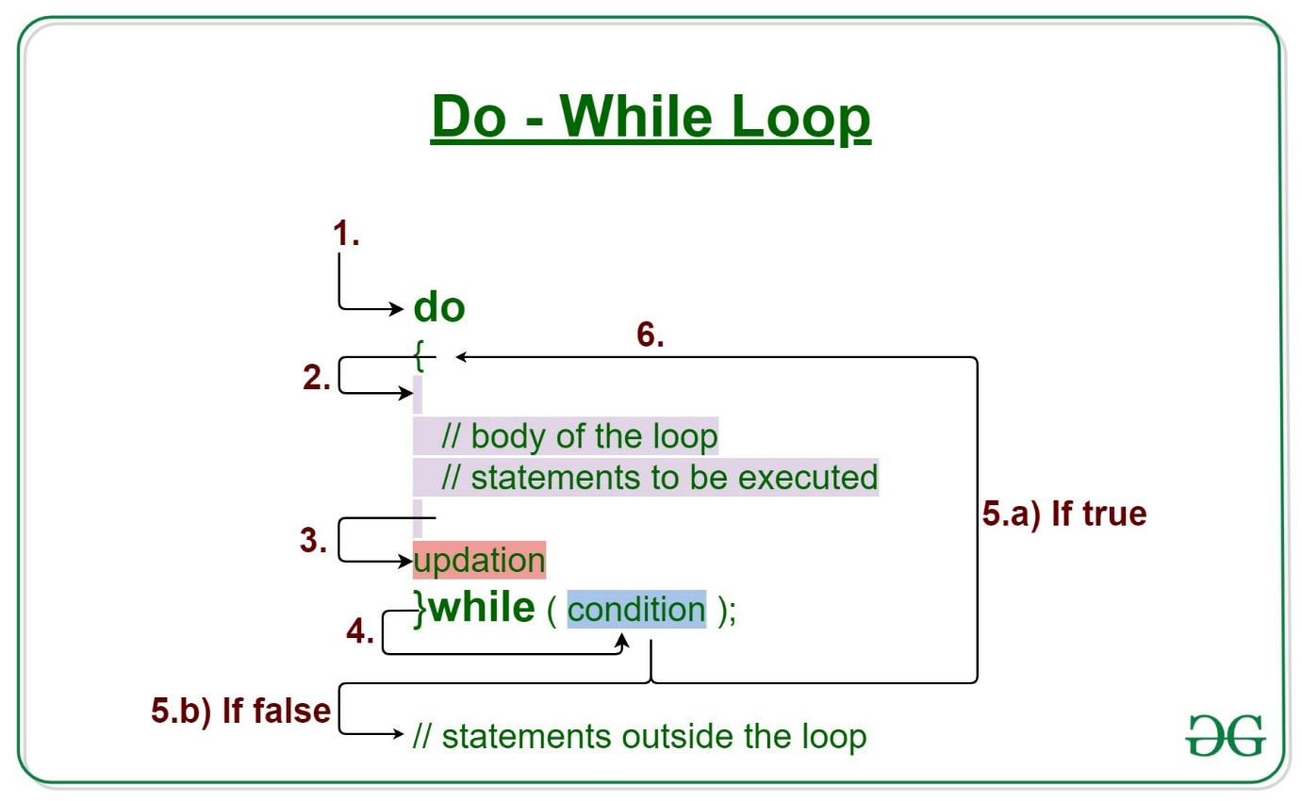

General Syntax of do-while Loop
do {
// loop body
// update
} while (condition);
⚠️ Semicolon ; is mandatory after while(condition)

🔑 Core Syntax Rule (MOST IMPORTANT)
In do-while, the loop body executes FIRST,
then the condition is checked.

Step-by-Step Execution Flow (Exact Syntax Flow)

Step 1️⃣ do block starts
do {
// body
}
- Loop body executes unconditionally
- Runs at least once

Step 2️⃣ Loop body executes
- All statements inside { } execute
- Includes update statements

Step 3️⃣ Condition is checked
while (condition);
- Condition must be a boolean expression
- Checked after body execution

Step 4️⃣ If condition is true
- Control jumps back to do
- Loop body executes again

Step 5️⃣ If condition is false
- Loop terminates
- Control moves to statements after the loop

Why do-while is called an exit-controlled loop
Because:
- Entry is unconditional
- Exit depends on condition
👉 Condition controls exit, not entry.

Important Syntax Rules

✔ Semicolon is mandatory
} while (i < 5); // ✔
} while (i < 5) // ❌ compile-time error

✔ Condition must be boolean
do { } while (true); // ✔
do { } while (i < 5); // ✔
do { } while (1); // ❌ invalid

Examples Showing Syntax Behavior

1️⃣ Condition false initially (still executes once)
int i = 10;
do {
System.out.println(i);
} while (i < 5);
Output:
10

2️⃣ Normal do-while
int i = 0;
do {
System.out.println(i);
i++;
} while (i < 5);

Comparison with while (Syntax Only)
Feature | while | do-while
Condition checked | Before body | After body
Executes at least once | ❌ | ✔️
Semicolon after condition | ❌ | ✔️

🌟 Ultra-Simple Notes (Perfect)
do-while executes the body first and checks the condition later.
The loop runs at least once.
Semicolon after while(condition) is compulsory.

Eg: Do_While
// go through the code

Eg: Do_While_Eg2
// go through the code

Eg: Do_While_Eg3
// go through the code

Eg: Do_While _Eg4

The code in question
do;
while (true);

Step 1: Understand what ; really means
In Java:
;
✔ This is a valid statement
✔ It is called an empty statement
✔ It does nothing
So yes, your statement is correct:
Semicolon is also considered a statement

Step 2: What does do-while syntactically require?
The exact syntax of do-while is:
do
statement
while (condition);
Important:
- After do, Java expects exactly one statement
- That statement can be:
  - a normal statement
  - a block { }
  - an empty statement ;

Step 3: How Java parses your code
Your code:
do;
while (true);
Java internally sees it as:
do
; // empty statement → loop body
while (true); // condition
So this is equivalent to:
do {
// empty body
} while (true);
✔ Perfectly valid
✔ No compile-time error
✔ Infinite loop
✔ Does nothing inside the loop

Step 4: Why earlier confusion happens (very important)
People get confused because:
- while(true); by itself is also valid
- ; is invisible (does nothing)
- So it looks like two separate statements
But Java grammar binds do with the immediately following while(condition);
They form ONE single construct.

Step 5: Why this does NOT cause unreachable statement error
Because:
- Java allows infinite loops
- There is no statement after the loop
- So nothing is proven unreachable
If you wrote this:
do;
while (true);
System.out.println("hi");
❌ THEN you would get unreachable statement error

Step 6: About your NOTE on declarations (important and correct)
Your note is correct, just let’s state it precisely:
If curly braces {} are NOT used,
a loop body can have only ONE statement,
and that statement CANNOT be a declaration.

❌ Invalid
do
int x = 10;
while (true);

✅ Valid
do {
int x = 10;
} while (true);
This rule is independent of the empty-statement case.

Final clean notes (keep this 👇)
- ; is a valid empty statement
- do; while(true); is valid Java
- It creates an infinite do-while loop
- The loop body is empty
- do and while are one combined statement

Eg: Do_While_Eg5
// go through the code

Eg: Do_While_Eg6
// go through the code.

Eg: Do_While_Eg7
// go through the code

Eg: Do_While_Eg8
// go through the code

Eg: Do_While_Eg9
// go through the code

Eg: Do_While_Eg10
// go through the code

Eg: Do_While_Eg11
// go through the code

Eg: Do_While_Eg12
// go through the code

Eg: Do_While_Eg13
// go through the code

